(Approx. 351 words)

Open Source Lab
Software Management for Mint
By Cal Esneault, former President of CCCC and leader of many Open Source Workshops & SIGs, Cajun Clickers Computer Club, LA
April 2014 issue, Cajun Clickers Computer News
www.clickers.org
ccnewsletter (at) cox.net

For convenience, most Linux distributions pre-compile source versions of programs into binary form so they will run immediately on your PC. The compiled results are available in the distribution's "repository" location. They will typically provide a software manager program with appropriate links to the repository. On my Linux Mint 16 installation, this program is simply called "Software Manager." A section of the start-up page of this program is shown below.
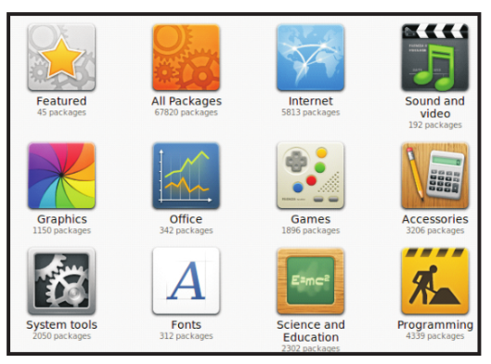

You can choose to view all available items or just those installed on your system (default is "all"). A simple graphical interface lets you select from a variety of categories to reduce the clutter from viewing all the thousands of available applications. Below is the result after selecting the "Featured" category.

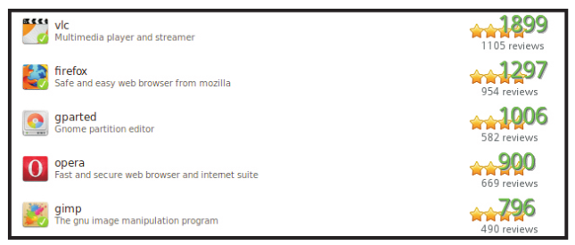

A green "check" denotes which items are already installed on the computer. This category ranks applications by popularity. In any category, you can also search for specific text. After choosing the "gparted" program, the following screen appeared.

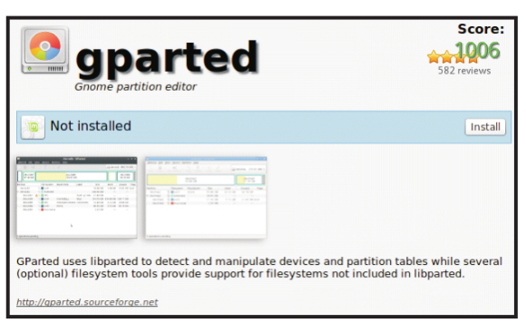
Screenshots of the application and a brief functional summary are given. Also, any user review comments will follow (not shown). To get the program, simply click on the "Install" button and it will be downloaded and installed. Any other required associated programs (call "dependencies") will also be installed.

An alternative package manager called "Synaptic" is also included (see below). Its layout is a little more complex, but it is used by many other distro's (for example, PCLinuxOS). Note below that the name "calligra" gets the complete office suite, but the other sub-programs are also listed and there is no obvious differentiation marking the main program without clicking on each item and reading the detailed text.

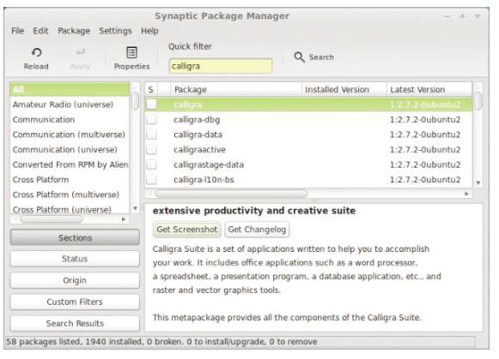

My personal preference in Linux Mint is to use the simpler "Software Manager" approach. I appreciate its user-friendly organization and the absence of commercial packages that are not cost-free. Check out Linux Mint at www.linuxmint.com to see more details.

